Optimist Club of Hernando
By providing hope and positive vision, Optimists bring out the best in kids. – Optimist Mission Statement

The Optimist Club of Hernando is making preparations for the 51st annual A’Fair Arts and Crafts in Hernando, which will be May 17, 2025! Over the past 51 years the festival has grown from just a few booths and a small crowd to over 250 booths and nearly 10,000 visitors. It is the largest community event in our county. Each year our community looks forward to our annual arts and crafts festival to welcome Spring, purchase local arts and crafts and visit with friends and visitors. Our city reaps the benefits of visitors from other cities in our county and the tri-state region.

We would like to invite you to participate as a sponsor of the 2025 A’Fair in Hernando!

Proceeds of the A’Fair benefit over 1,000 children in our community by their participation in our activities, events and donations, and we hope that you will be a part of this event so that we can continue to increase the number of lives we touch.

We have enclosed sponsorship information for you that outlines the benefits of the various sponsorship levels including advertising and booth space.

The Optimist Club of Hernando is a member of the Optimist International Organization. For more information regarding the International Organization please go to www.optimistinternational.org.

If you have any questions or need more information, please contact us. www.HernandoOptimist.org

Sincerely,

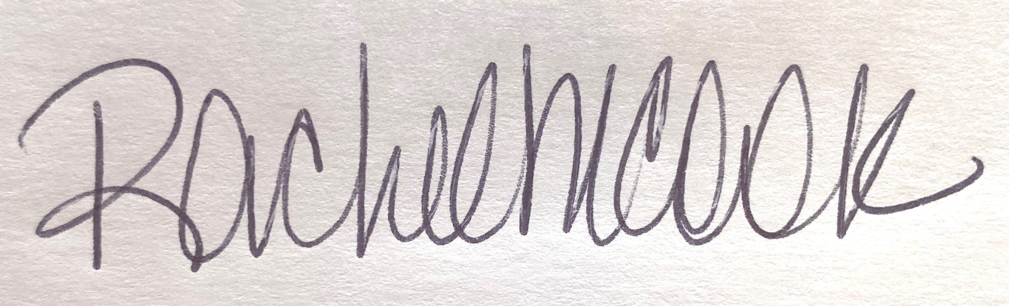

Rachel M. Cook
901-258-6811

Optimist Club of Hernando

By providing hope and positive vision, Optimists bring out the best in kids. – Optimist Mission Statement

2025 Sponsorship levels

Platinum Sponsor ($1000)
- Listed as Platinum Sponsor with logo on all advertising
**send logo to rachelmcook@aol.com
- A’Fair t-shirts - Listed as Platinum Sponsor with logo
- Booth space at A’Fair free of charge
- Listed as Gold Sponsor with logo in all follow-up Thank you advertising

Gold Sponsor ($500)
- Listed as Gold Sponsor on all advertising
- A’Fair t-shirts - Listed as Gold Sponsor
- Listed as Gold Sponsor in all follow-up Thank you advertising
Silver Sponsor ($250)
- A’Fair t-shirts - Listed as Silver Sponsor

Optimist Club of Hernando

PAID SOCIAL MEDIA ADVERTISING

Facebook
Promoted weekly 3 weeks before event Daily and Boosted
Recognition at sponsor level
Follow-up Thank You promotion following event

MAGAZINE ADVERTISING

Southern Shopper
½ page ad in May publication

Optimist Club of Hernando

A’Fair Arts and Crafts in Hernando – May 17, 2025

Company Name: ______________________________________________________

Contact Person: _______________________________________________________

Address: _____________________________________________________________

City: ________________ State: ________________ Zip: ________________

Phone: ______________________ Email: ________________________________

Please accept our support for 2025 A’Fair in Hernando:

- Platinum Sponsor ($1000) $ _________________
**send logo to rachelmcook@aol.com
- Gold Sponsor ($500) $ _________________

- Silver Sponsor ($250) $ _________________

- My company is unable to sponsor at a level above, but would like to make a donation of

$ _________ or an in-kind donation of ____________________________________

Please make checks payable to Optimist Club of Hernando deadline is April 15th

Mail completed form with payment to:
Hernando Optimist Club
PO Box 532
Hernando, MS 38632

Or contact Rachel Cook (901-258-6811), or another Optimist Club member for pick up.

We appreciate your support of the Optimist Club of Hernando and the children in our community!

